HW 3
Part 1
1.1
The language accepted by A^2 is words of odd-numbered length, beginning and ending with a, with b never repeating.
1.2
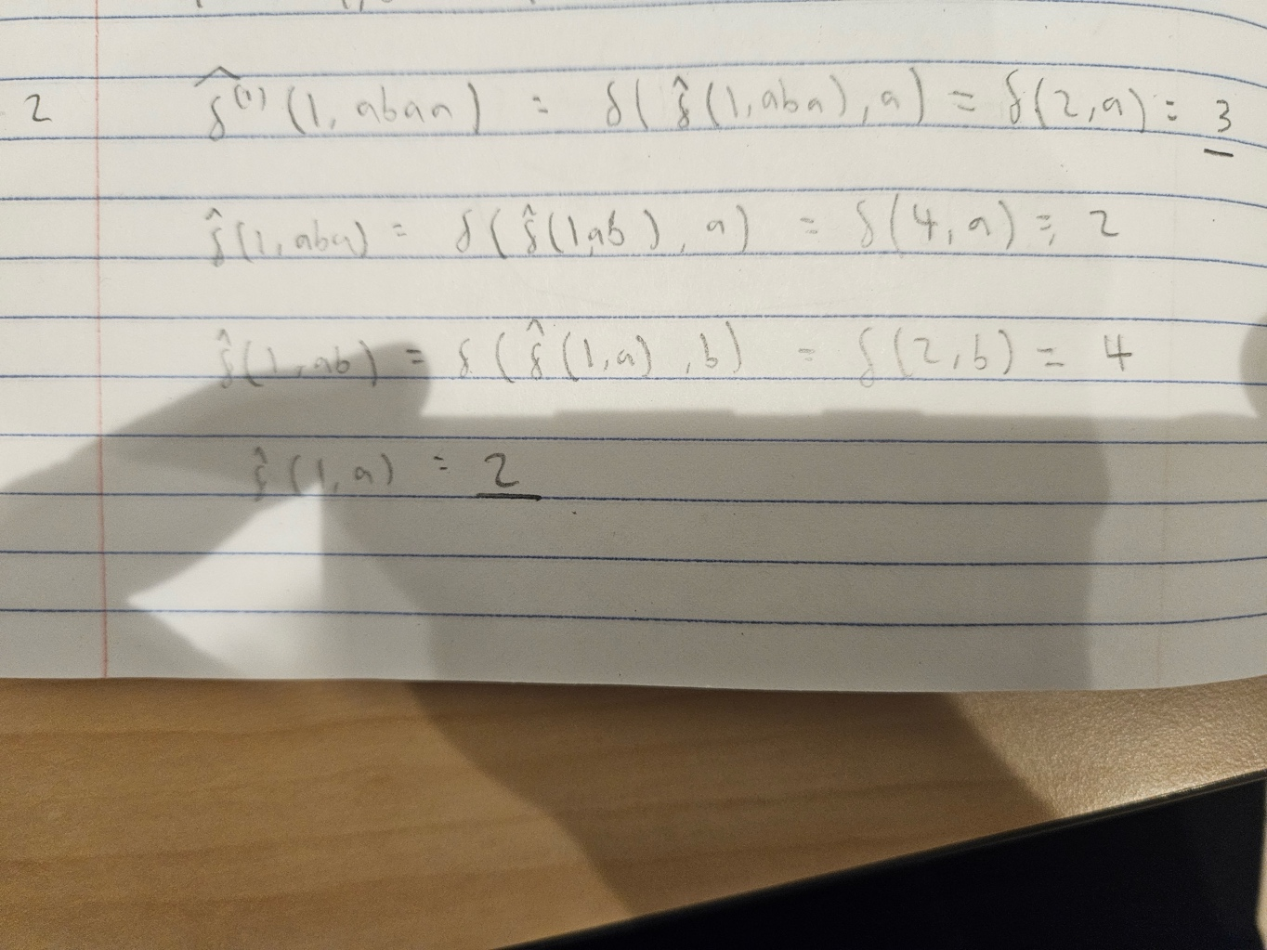
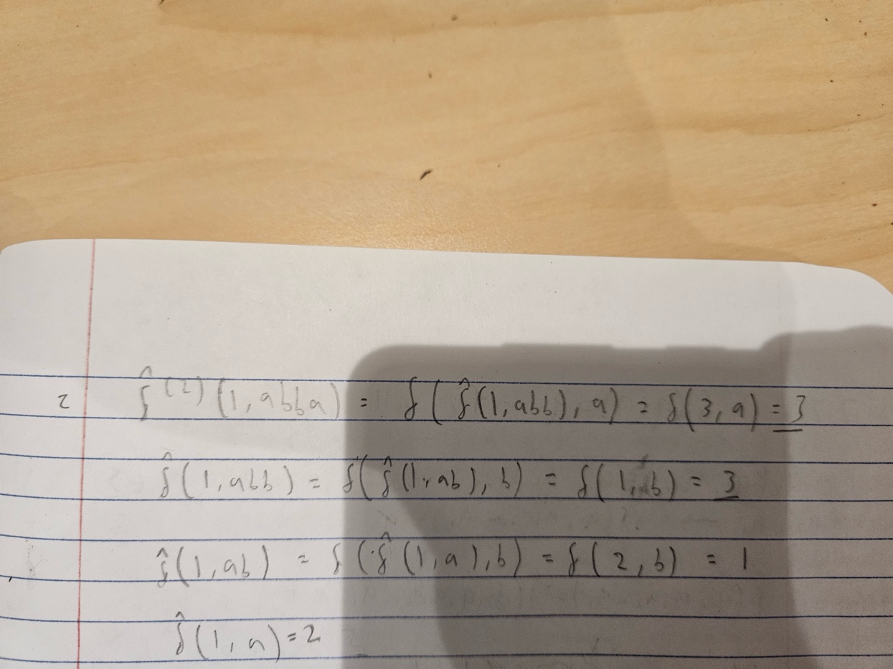
Part 2
2.1
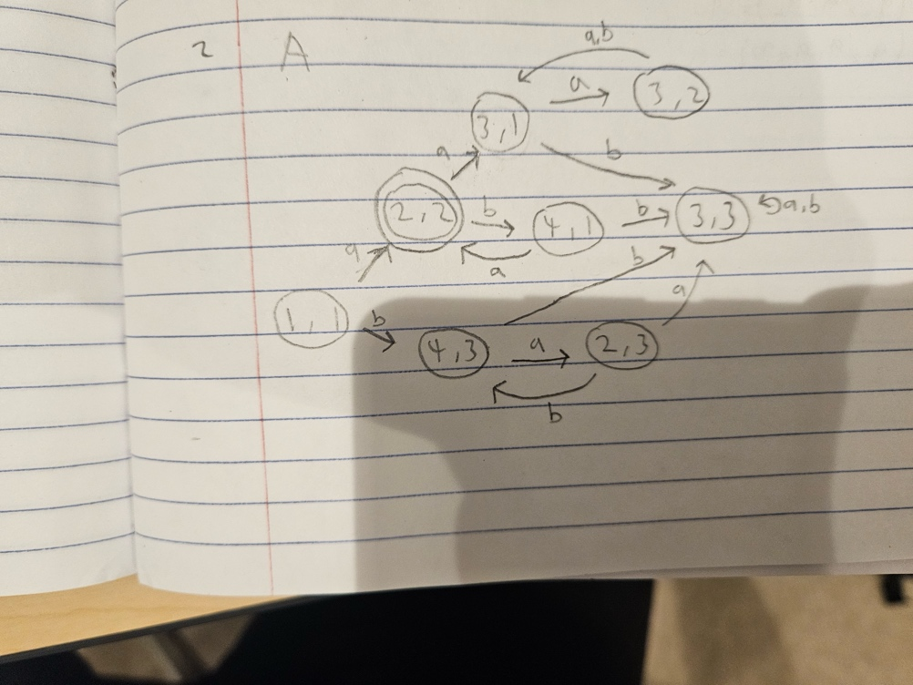
2.2
L(A) = L(A^1) \cap L(A^2) because L(A^1) and L(A^2) are only defined by the states and transitions of A^1 and A^2, which is information
L(A) preserves entirely, without adding any new information not found in either L(A^1) or L(A^2). Also, A does not accept a word
unless it is accepted in both A^1 and A^2, without accepting words ending in states that are uniquely by accepted by A^1 or A^2.

2.3
One way to change A would be to add a redundant state. Such as the state (3,3), which in A always transitions back into itself. In A', (3,3) could lead into a new state where it then gets stuck as it would at state (3,3) in A. This way it would function the same while being technically different.

2.27

